Open Zigzag Polygonal Shape
# Source: AI Source: Provided by: [Data Path: Persons Table -> ID Column: 1, Name_En Column: Motasem Essam] -> From: [ChatGPT] on [7/25/2026]
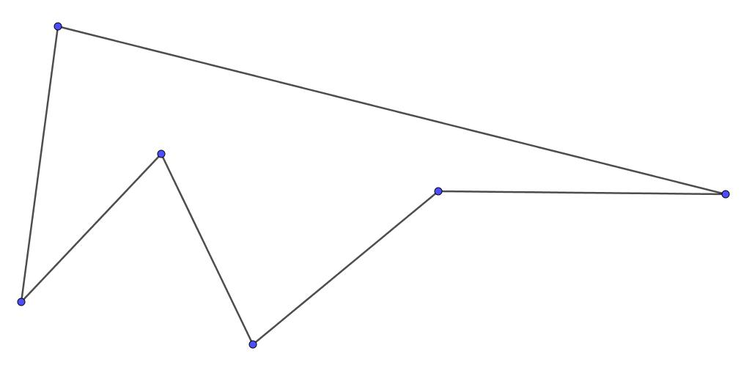
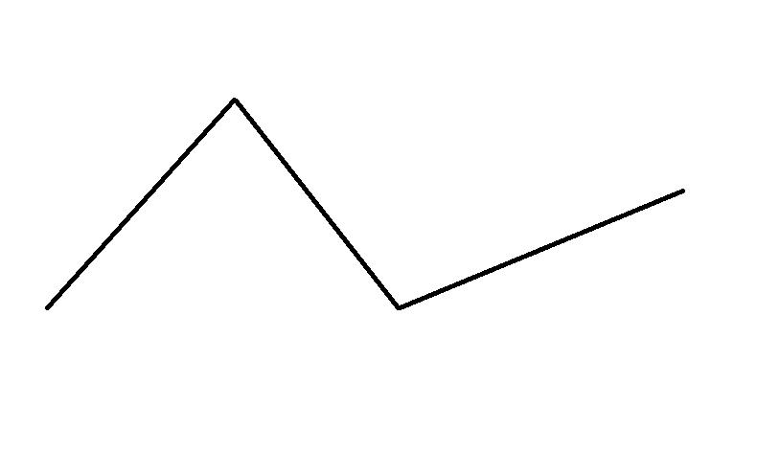
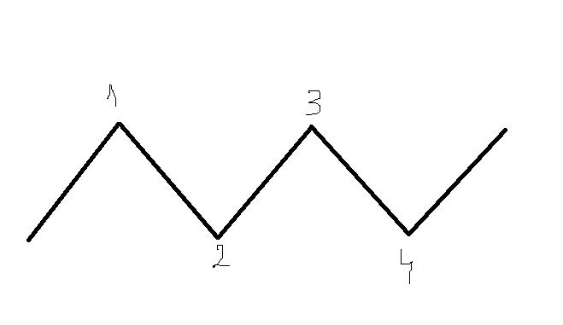
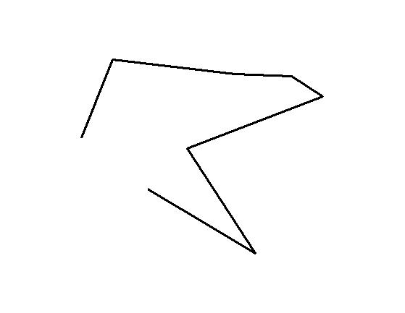

Definition
# Source: AI Source: Provided by: [Data Path: Persons Table -> ID Column: 1, Name_En Column: Motasem Essam] -> From: [ChatGPT] on [7/25/2026]
An Open Zigzag Polygonal Shape is an open polygonal path made of three or more straight line segments connected end-to-end, where the direction changes repeatedly and the final endpoint does not connect back to the starting point.
$$\boxed{\text{Open Zigzag Polygonal Shape}=\text{Multiple Straight Segments}+\text{Repeated Direction Changes}+\text{Open Boundary}}$$
It resembles a zigzag or back-and-forth path rather than a closed polygon.

Characteristics
# Source: AI Source: Provided by: [Data Path: Persons Table -> ID Column: 1, Name_En Column: Motasem Essam] -> From: [ChatGPT] on [7/25/2026]
An Open Zigzag Polygonal Shape:
- Is open.
- Contains three or more straight line segments.
- Has connected consecutive segments.
- Changes direction at one or more internal vertices.
- Has two unconnected endpoints.
- Does not enclose an area.
- Can have equal or unequal segment lengths.
- Can have regular or irregular angle changes.
- Can be symmetric or asymmetric.
A simple example can be represented as:
$$\boxed{A→B→C→D→E}$$
with the segments changing direction at $B$, $C$, and $D$.

Types of Open Zigzag Polygonal Shapes

1. Simple Open Zigzag Shape
# Source: AI Source: Provided by: [Data Path: Persons Table -> ID Column: 1, Name_En Column: Motasem Essam] -> From: [ChatGPT] on [7/25/2026]
A basic zigzag with several connected straight segments and no self-intersection.
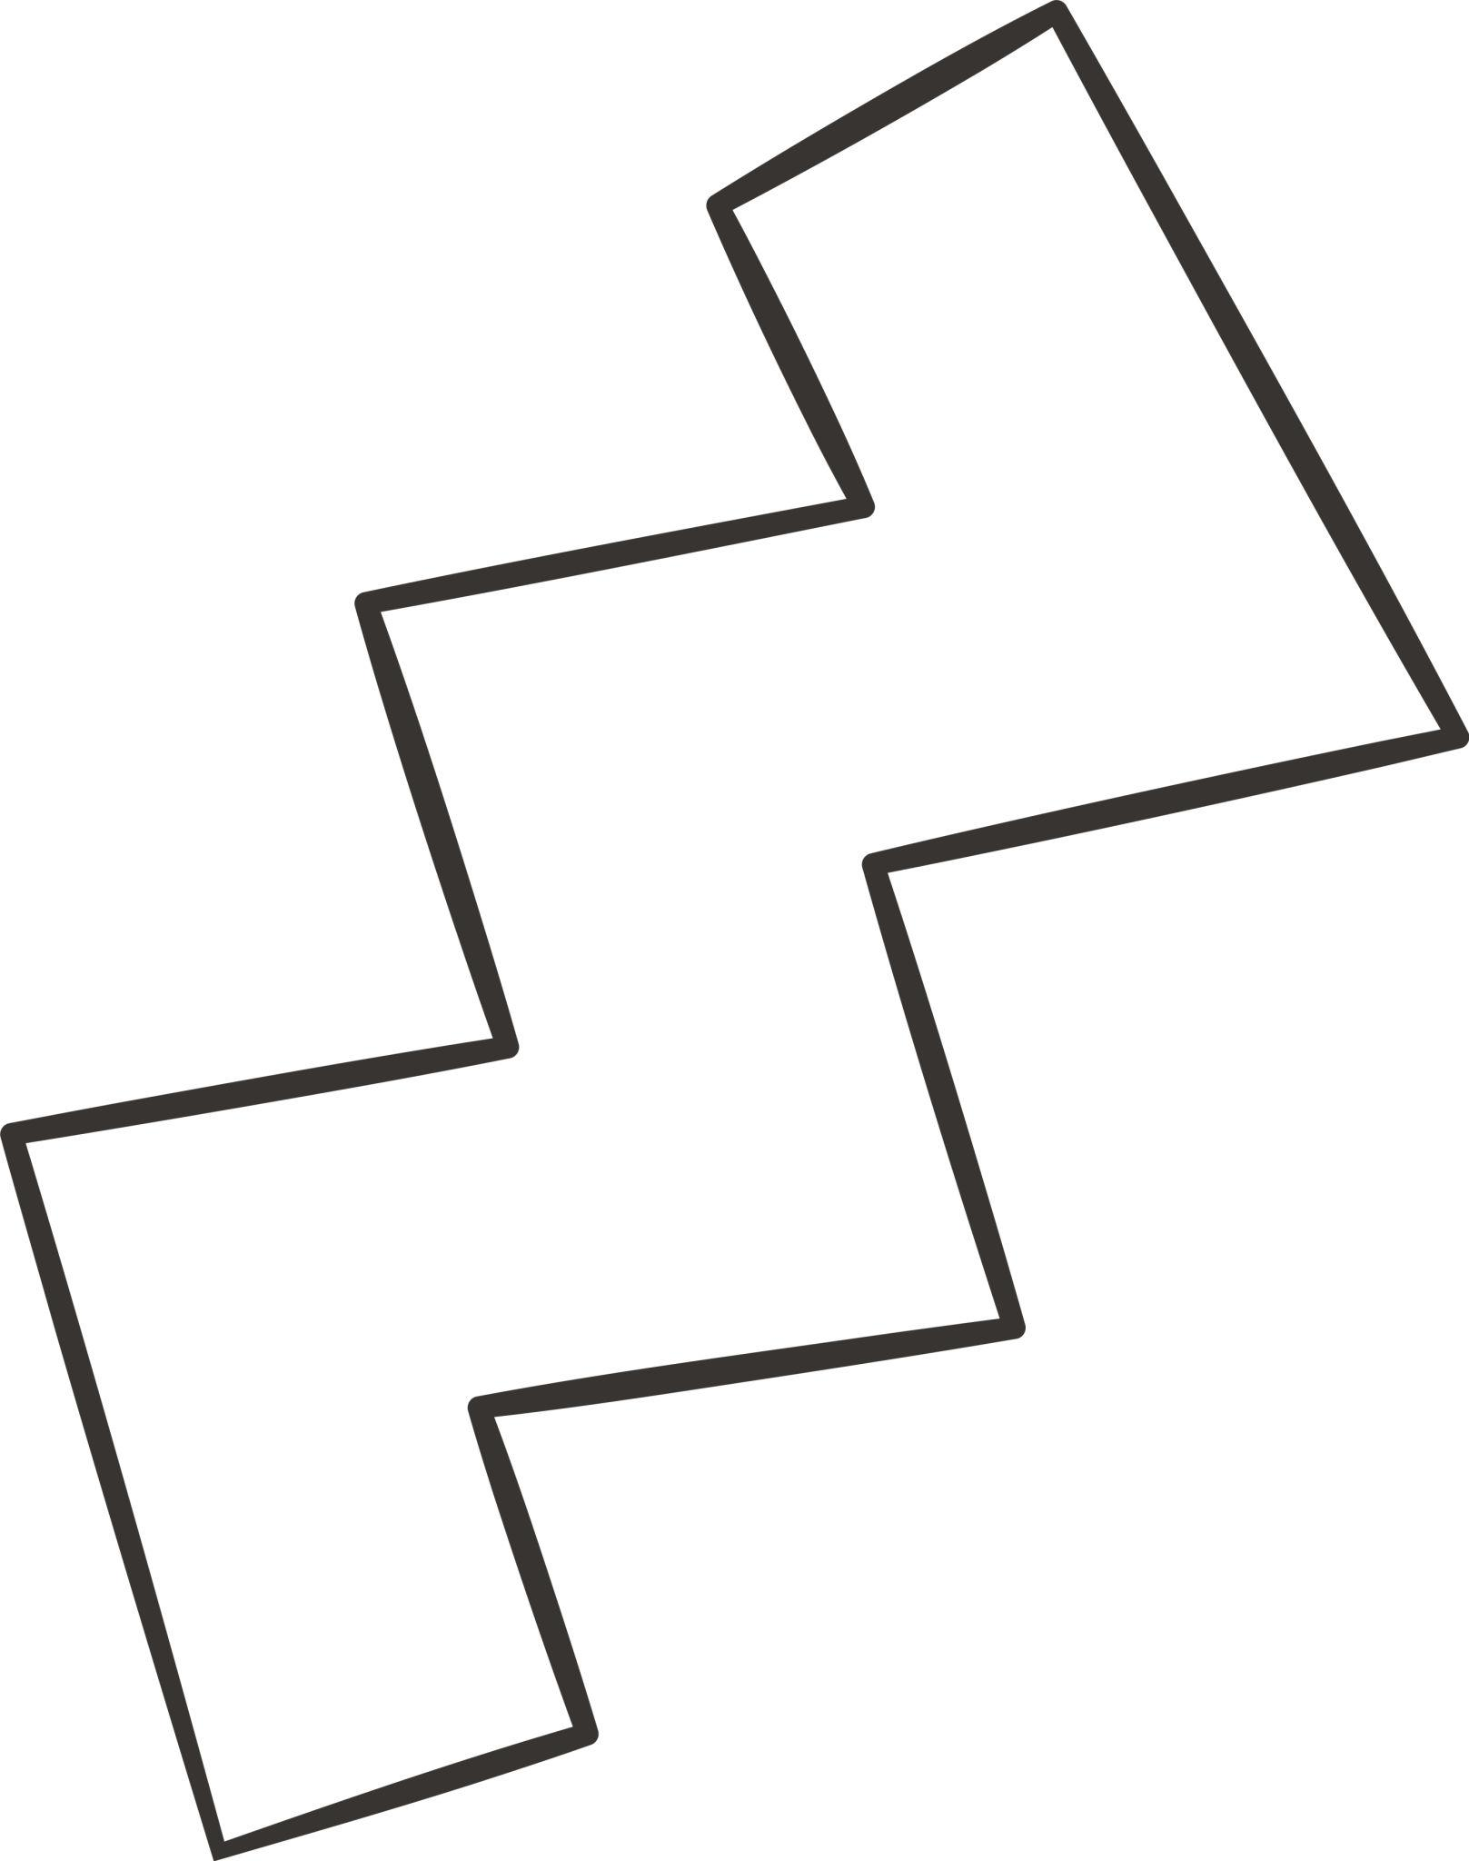
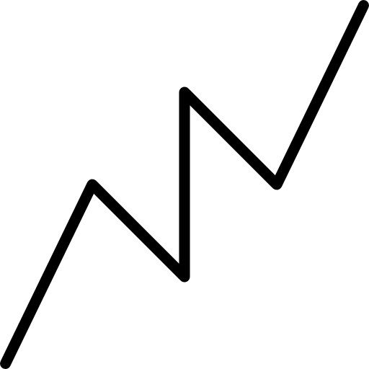
This is the simplest form of an open zigzag polygonal shape.

2. Open V-Zigzag Shape
# Source: AI Source: Provided by: [Data Path: Persons Table -> ID Column: 1, Name_En Column: Motasem Essam] -> From: [ChatGPT] on [7/25/2026]
The path repeatedly forms V-like turns.
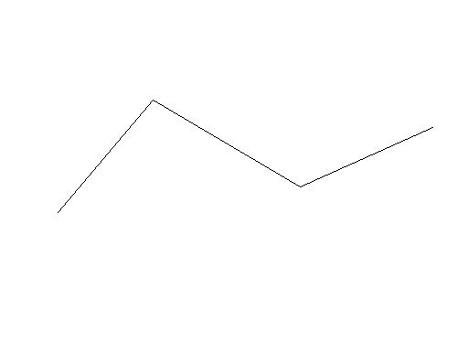
Each pair of adjacent segments forms a V-like angle.

3. Open W-Zigzag Shape
# Source: AI Source: Provided by: [Data Path: Persons Table -> ID Column: 1, Name_En Column: Motasem Essam] -> From: [ChatGPT] on [7/25/2026]
The path contains several connected V-shaped turns, producing a W-like appearance.
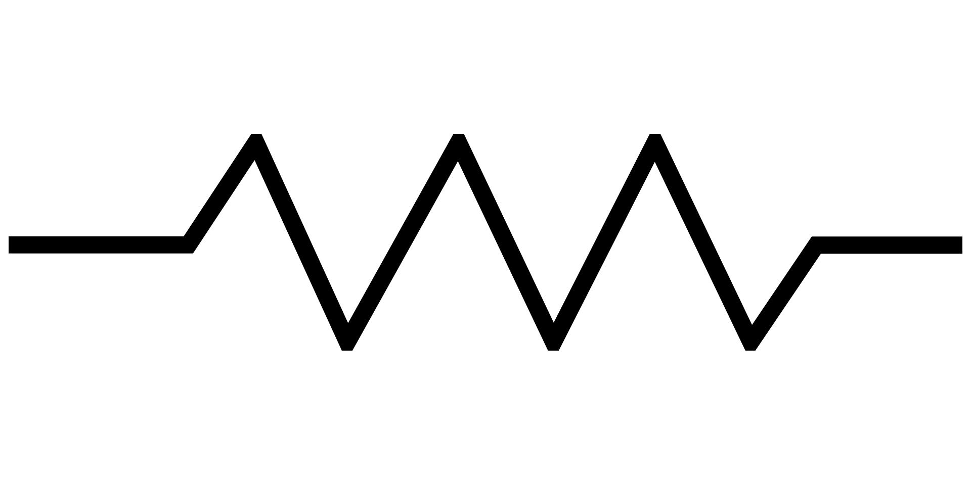
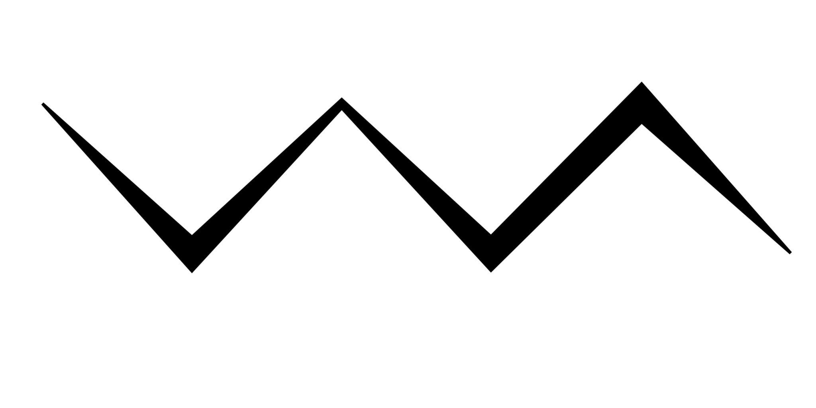
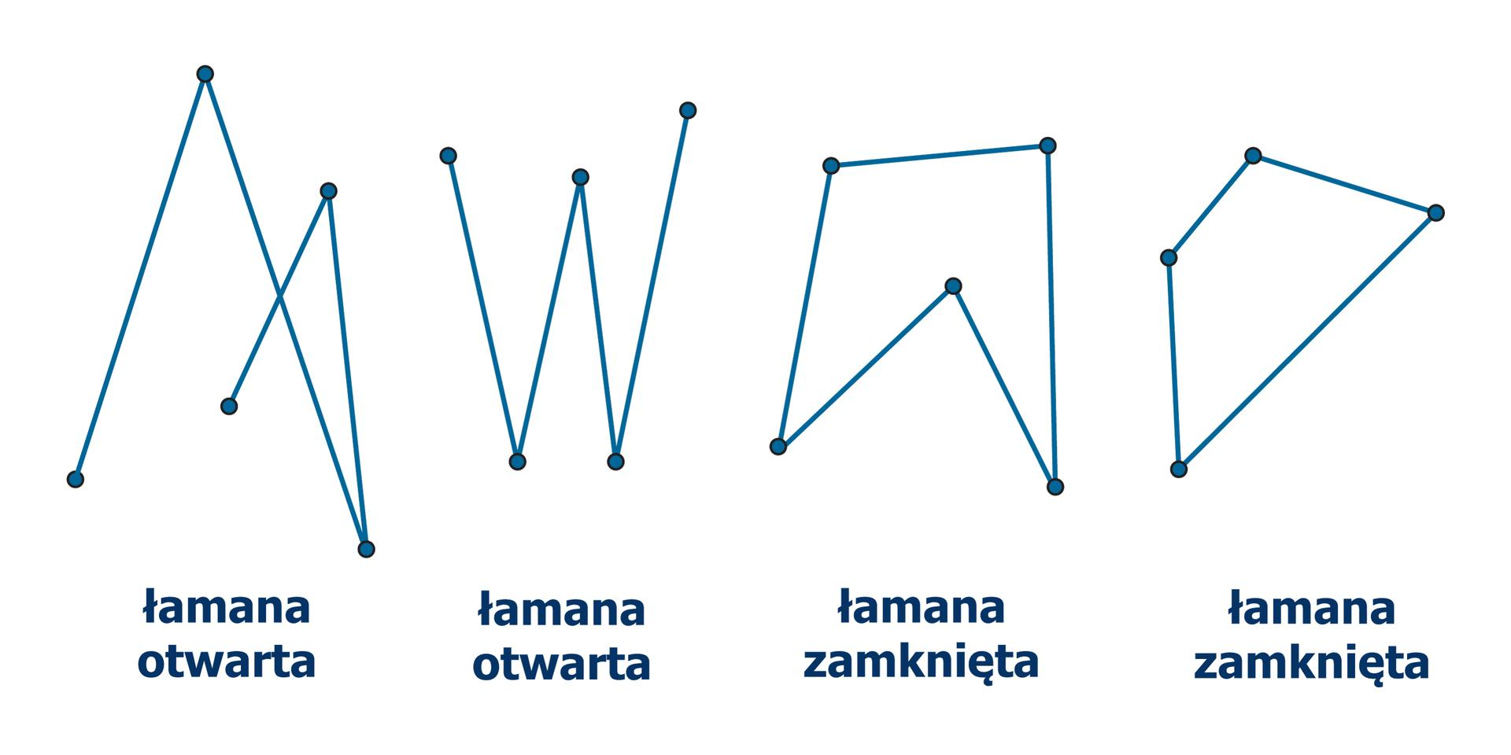

4. Open Stair-Zigzag Shape
# Source: AI Source: Provided by: [Data Path: Persons Table -> ID Column: 1, Name_En Column: Motasem Essam] -> From: [ChatGPT] on [7/25/2026]
The segments alternate between horizontal and vertical directions.
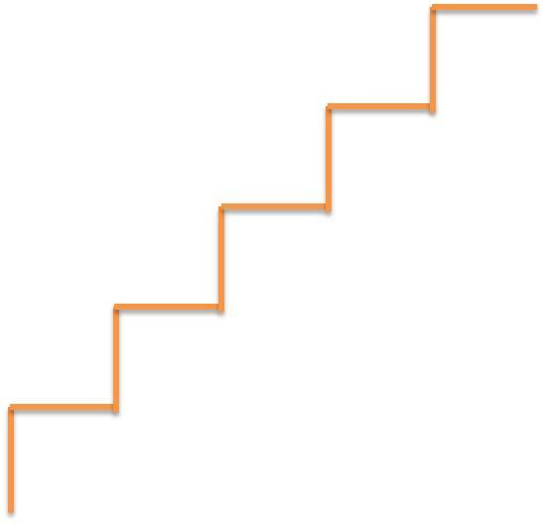
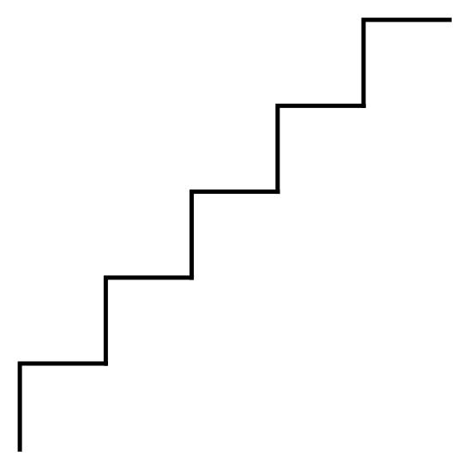
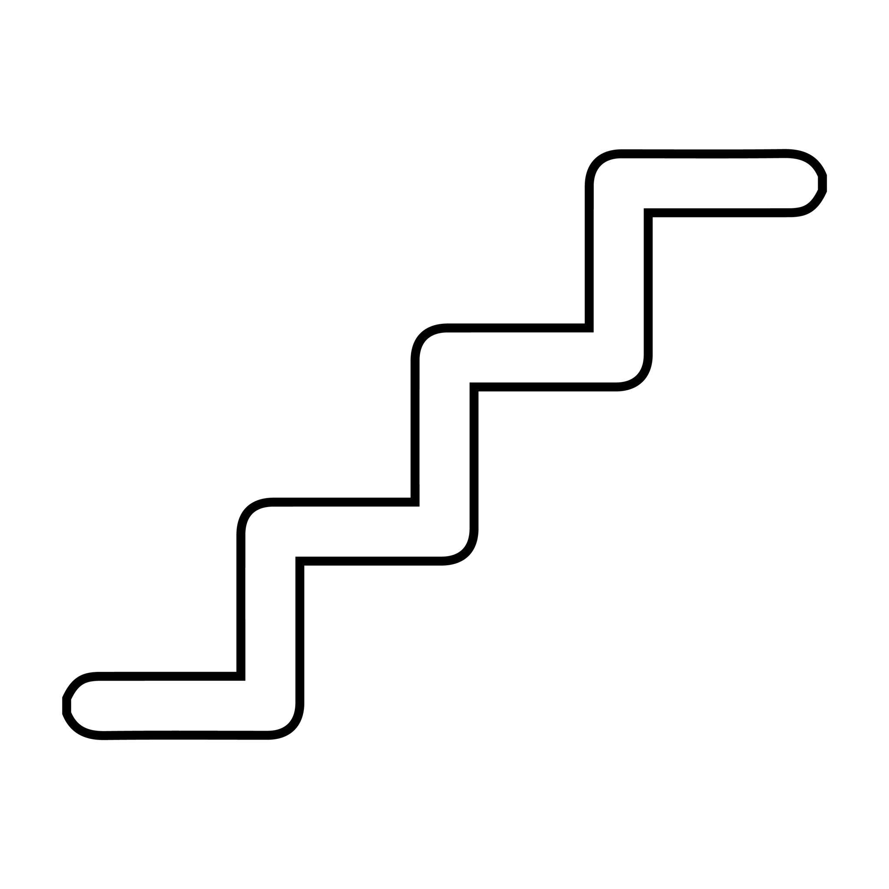
A typical sequence is:
$$\boxed{→↑→↑→}$$

5. Symmetric Open Zigzag Shape
# Source: AI Source: Provided by: [Data Path: Persons Table -> ID Column: 1, Name_En Column: Motasem Essam] -> From: [ChatGPT] on [7/25/2026]
The two sides of the zigzag are arranged symmetrically around an axis.
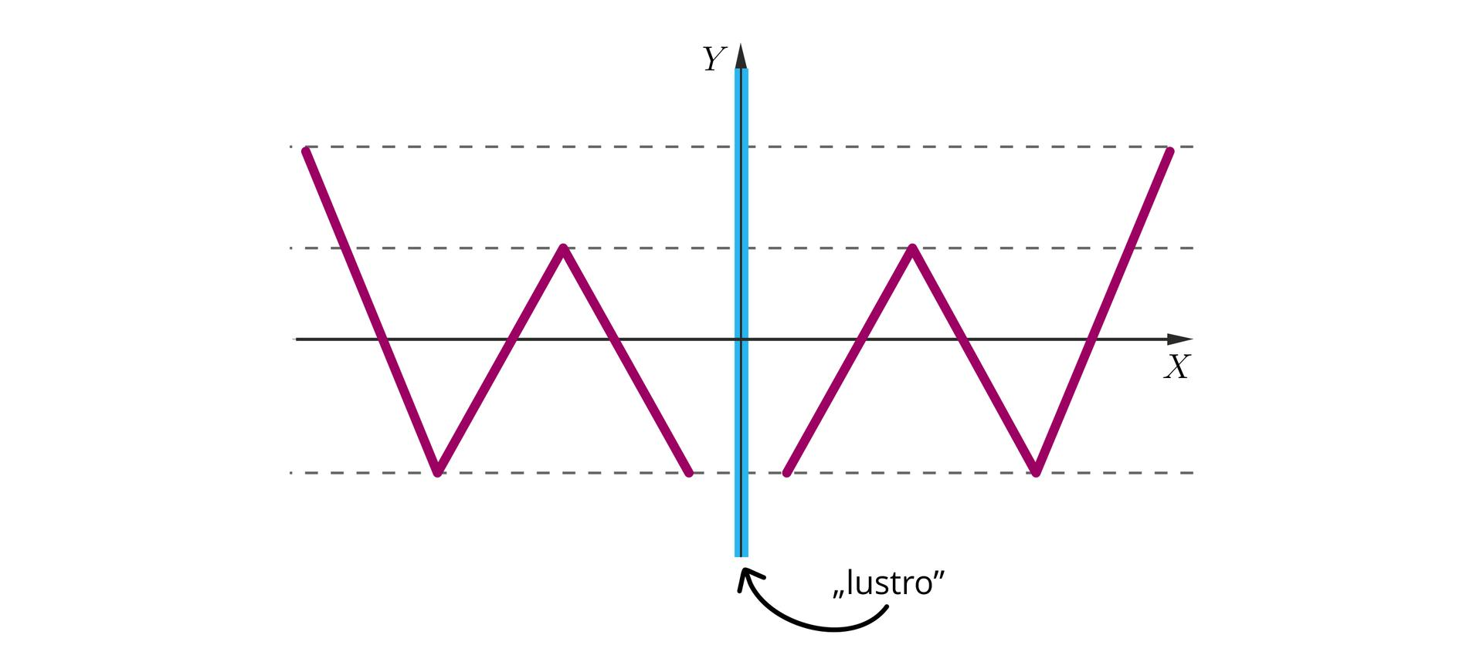
Symmetry does not make the shape closed.
$$\boxed{\text{Open}+\text{Symmetric}}$$
is still an open shape.

6. Asymmetric Open Zigzag Shape
# Source: AI Source: Provided by: [Data Path: Persons Table -> ID Column: 1, Name_En Column: Motasem Essam] -> From: [ChatGPT] on [7/25/2026]
The segments and angles are arranged without regular symmetry.
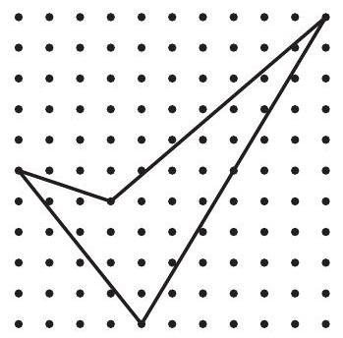
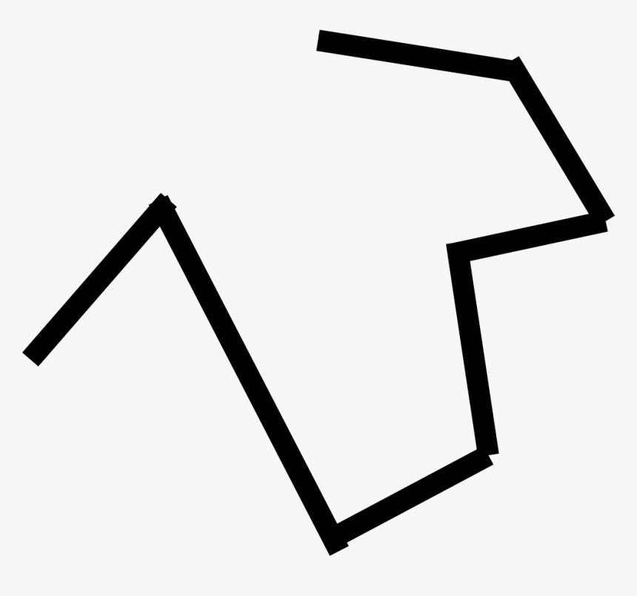
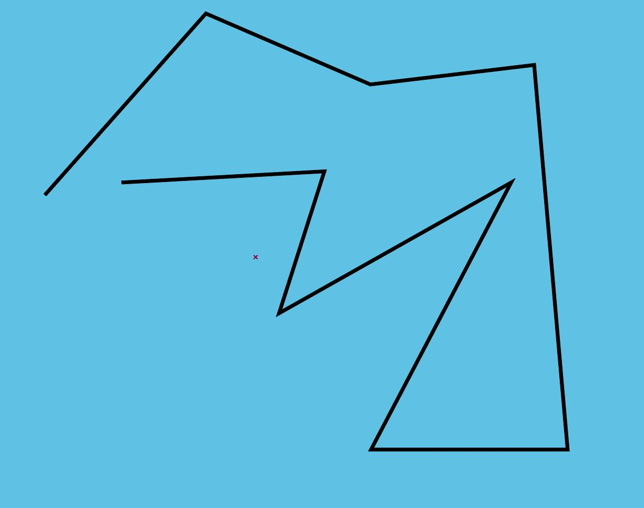
The segments may have different:
- Lengths.
- Angles.
- Directions.
- Spacing.

7. Equal-Segment Open Zigzag Shape
# Source: AI Source: Provided by: [Data Path: Persons Table -> ID Column: 1, Name_En Column: Motasem Essam] -> From: [ChatGPT] on [7/25/2026]
All segments have equal length:
$$\boxed{L_{1}=L_{2}=L_{3}=⋯=L_{n}}$$
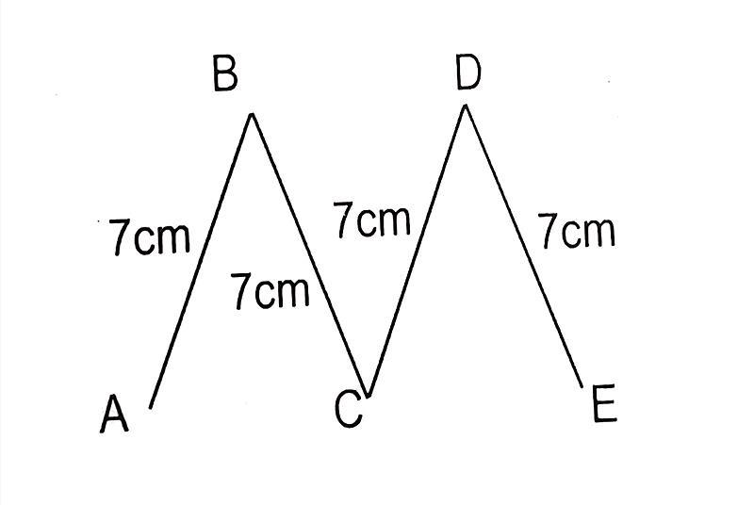
Equal segment lengths do not make the figure a regular polygon because it remains open.

8. Unequal-Segment Open Zigzag Shape
# Source: AI Source: Provided by: [Data Path: Persons Table -> ID Column: 1, Name_En Column: Motasem Essam] -> From: [ChatGPT] on [7/25/2026]
The segments have different lengths.
$$\boxed{L_{1},L_{2},L_{3},…,L_{n}\text{ are not all equal}}$$
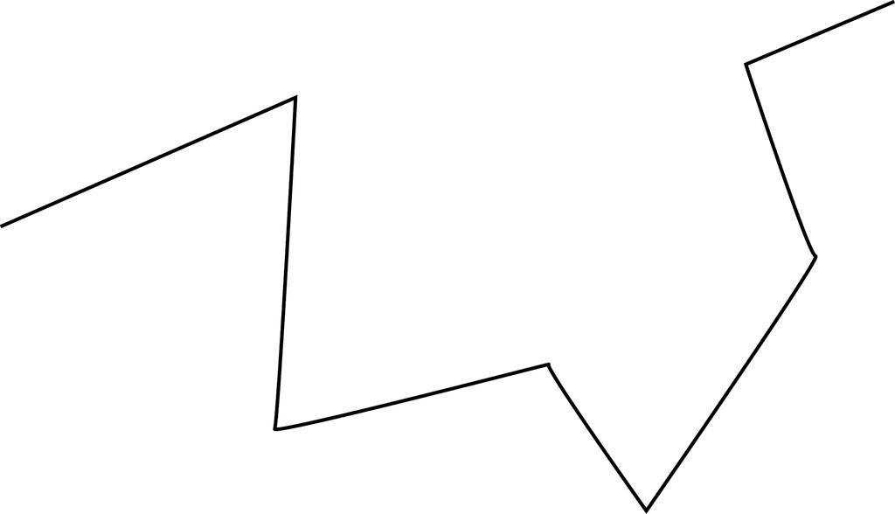
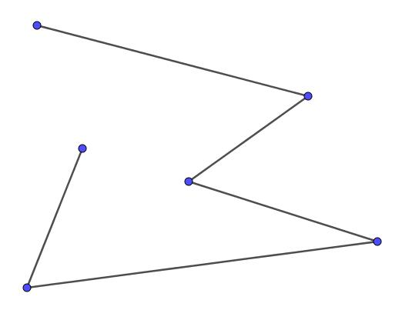
This is one of the most common irregular zigzag forms.

9. Acute-Angle Open Zigzag Shape
# Source: AI Source: Provided by: [Data Path: Persons Table -> ID Column: 1, Name_En Column: Motasem Essam] -> From: [ChatGPT] on [7/25/2026]
The direction changes produce acute turning angles.
$$0^{∘}<θ<{90}^{∘}$$
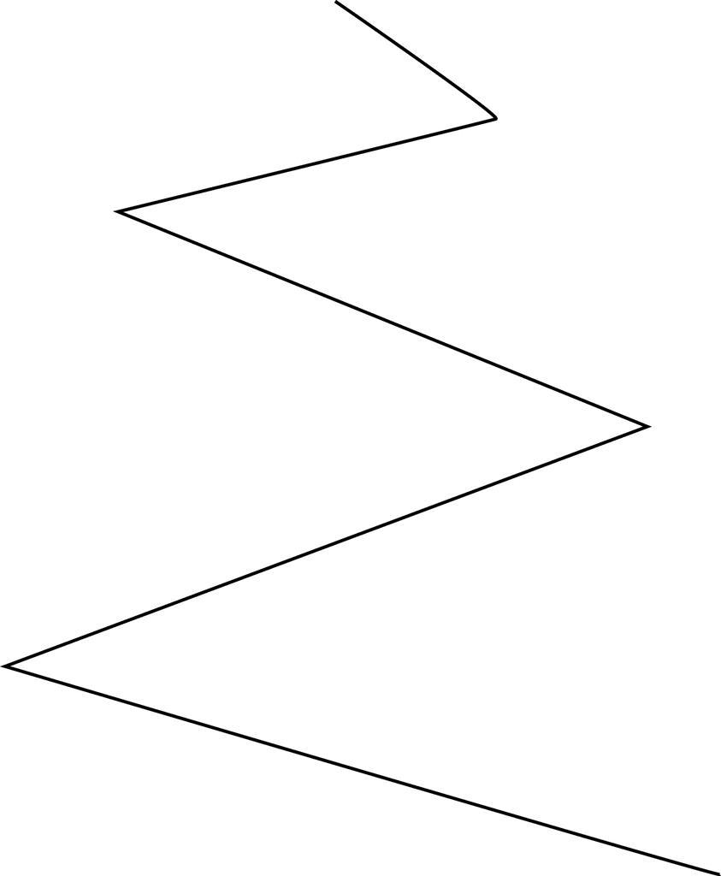
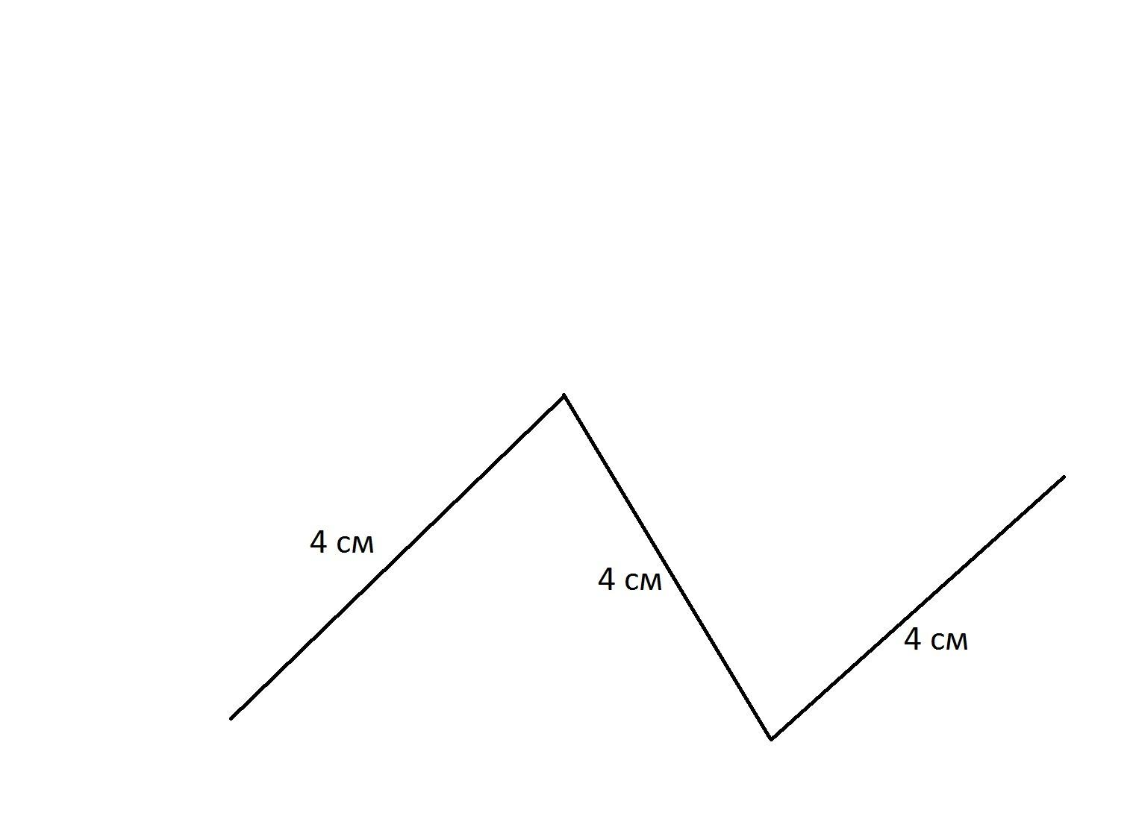

10. Right-Angle Open Zigzag Shape
# Source: AI Source: Provided by: [Data Path: Persons Table -> ID Column: 1, Name_En Column: Motasem Essam] -> From: [ChatGPT] on [7/25/2026]
The segments contain one or more right-angle turns.
$$\boxed{θ={90}^{∘}}$$
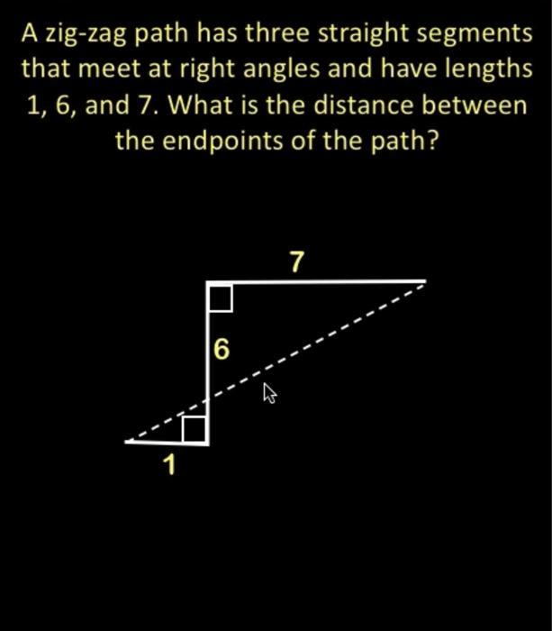
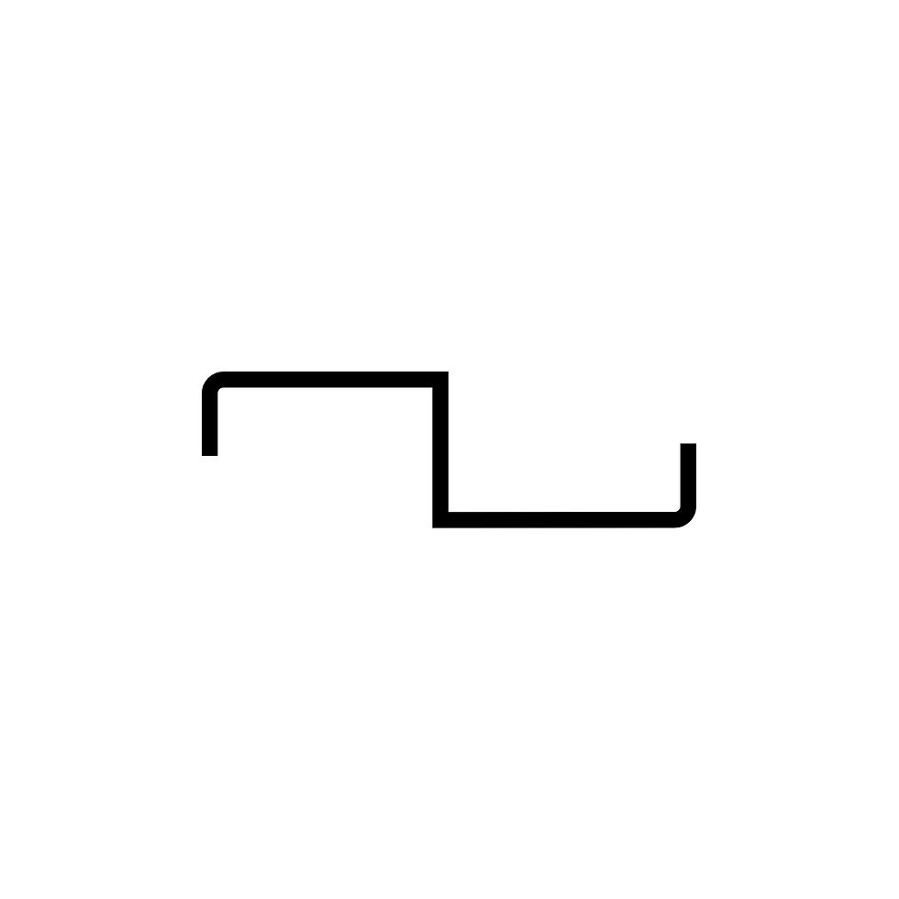
This often produces a staircase-like zigzag.

11. Obtuse-Angle Open Zigzag Shape
# Source: AI Source: Provided by: [Data Path: Persons Table -> ID Column: 1, Name_En Column: Motasem Essam] -> From: [ChatGPT] on [7/25/2026]
One or more turns involve obtuse angles.
$${90}^{∘}<θ<{180}^{∘}$$
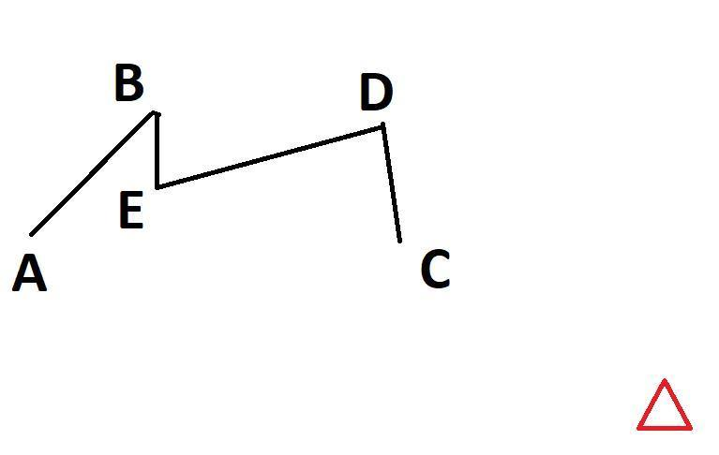
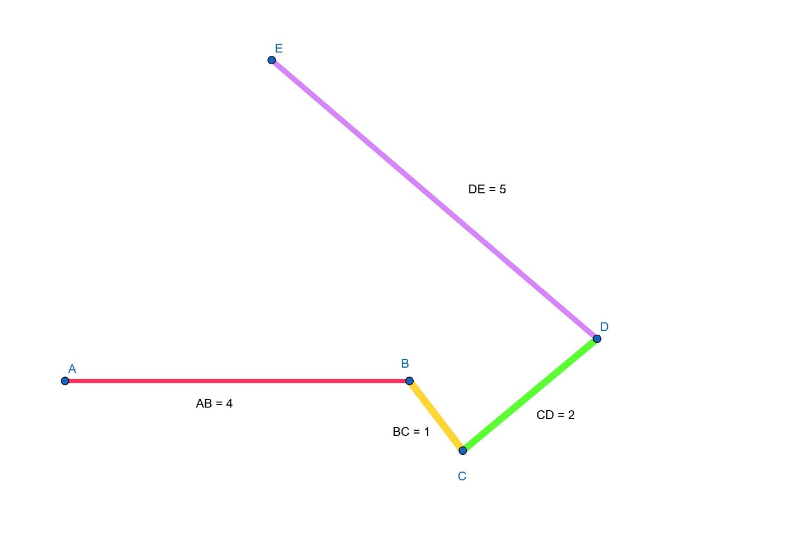

12. Self-Intersecting Open Zigzag Shape
# Source: AI Source: Provided by: [Data Path: Persons Table -> ID Column: 1, Name_En Column: Motasem Essam] -> From: [ChatGPT] on [7/25/2026]
The zigzag segments cross one another while the overall path remains open.
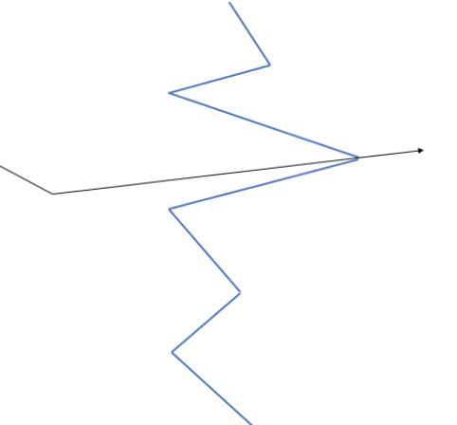
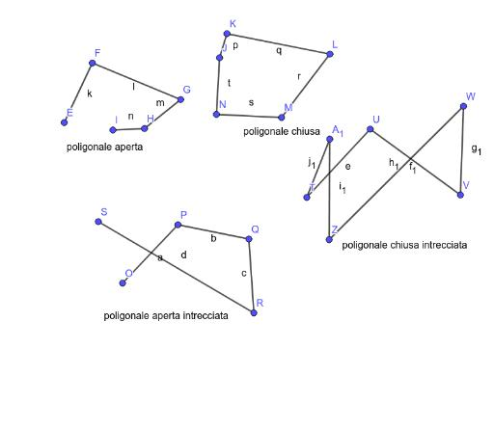
The figure is still open because its first and final endpoints are not connected.

Classification by Number of Segments
# Source: AI Source: Provided by: [Data Path: Persons Table -> ID Column: 1, Name_En Column: Motasem Essam] -> From: [ChatGPT] on [7/25/2026]
Open zigzags can also be classified by segment count:
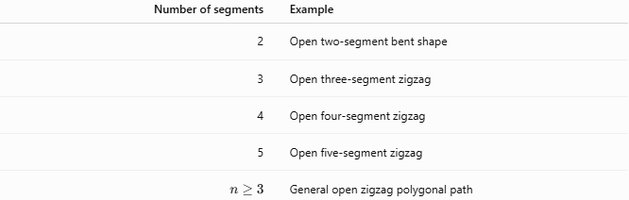
Number of segments | Example
2 | Open two-segment bent shape
3 | Open three-segment zigzag
4 | Open four-segment zigzag
5 | Open five-segment zigzag
(n\geq3) | General open zigzag polygonal path
For your classification system, it is useful to distinguish segment count from shape pattern.

Open Zigzag vs. Closed Zigzag Polygon
# Source: AI Source: Provided by: [Data Path: Persons Table -> ID Column: 1, Name_En Column: Motasem Essam] -> From: [ChatGPT] on [7/25/2026]
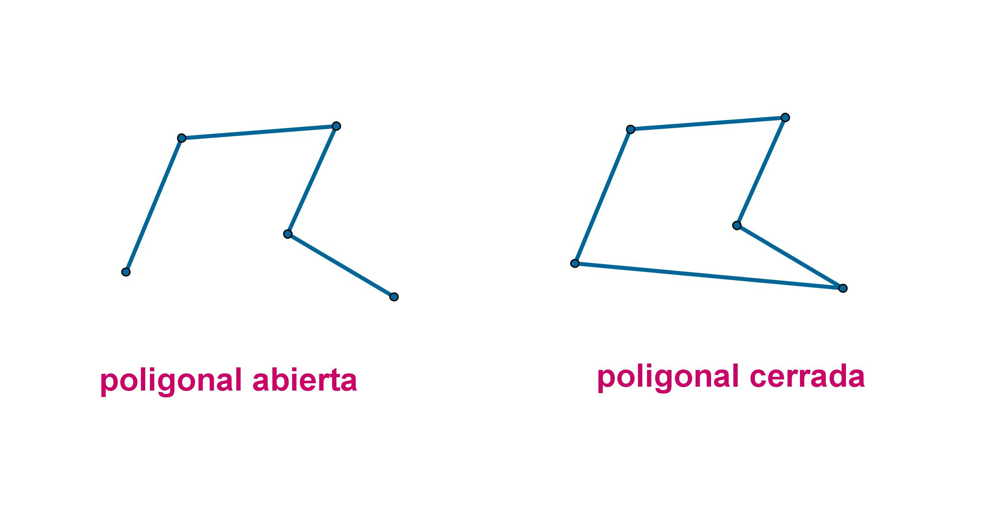
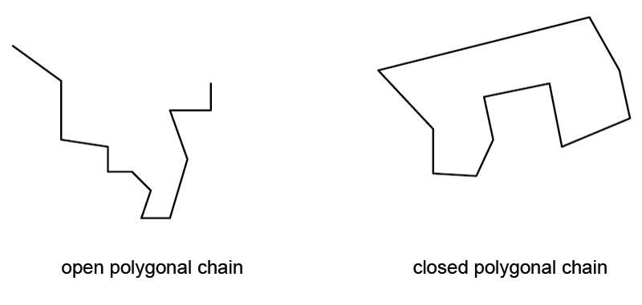
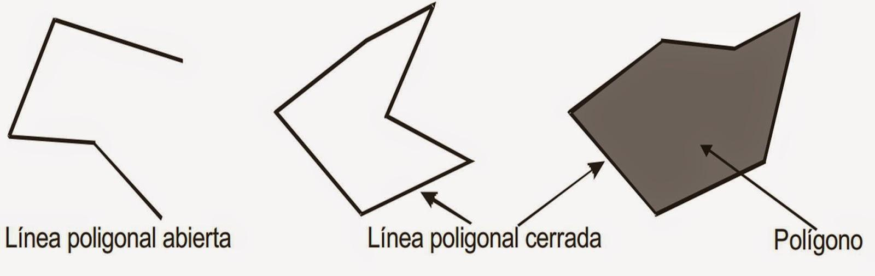
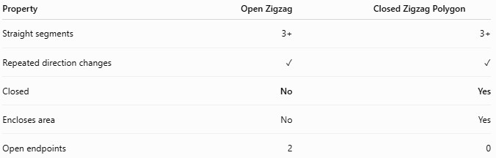
Property | Open Zigzag | Closed Zigzag Polygon
Straight segments | 3+ | 3+
Repeated direction changes | ✓ | ✓
Closed | No | Yes
Encloses area | No | Yes
Open endpoints | 2 | 0
The key difference is closure:
$$\boxed{A→B→C→D}$$
is open, while a path that eventually returns to $A$ is closed.

Area and Length
# Source: AI Source: Provided by: [Data Path: Persons Table -> ID Column: 1, Name_En Column: Motasem Essam] -> From: [ChatGPT] on [7/25/2026]
Area
An open zigzag does not enclose a region:
$$\boxed{A=\text{not an enclosed area}}$$
Total Length
Its total path length is:
$$\boxed{L=L_{1}+L_{2}+⋯+L_{n}}$$
where $L_{1},L_{2},…,L_{n}$ are the individual segment lengths.

Key Points
# Source: AI Source: Provided by: [Data Path: Persons Table -> ID Column: 1, Name_En Column: Motasem Essam] -> From: [ChatGPT] on [7/25/2026]
An Open Zigzag Polygonal Shape is:
$$\boxed{\text{Open}+\text{3 or More Straight Segments}+\text{Repeated Direction Changes}}$$
It:
- Has three or more straight line segments.
- Has consecutive segments connected end-to-end.
- Has two unconnected endpoints.
- Changes direction repeatedly at its vertices.
- Does not enclose a region.
- Therefore, it has no enclosed area.
- May have equal or unequal segment lengths.
- May be symmetric or asymmetric.
- May contain acute, right, obtuse, or straight turns.
- May be simple or self-intersecting.
- Can appear as V-shaped, W-shaped, staircase-like, or irregular zigzag paths.
Most important distinction
$$\boxed{\text{Open Zigzag}≠\text{Closed Polygon}}$$
A zigzag becomes a closed polygon only when its final endpoint connects back to its starting point.

Conclusion
# Source: AI Source: Provided by: [Data Path: Persons Table -> ID Column: 1, Name_En Column: Motasem Essam] -> From: [ChatGPT] on [7/25/2026]
An Open Zigzag Polygonal Shape is an open straight-line path consisting of three or more connected segments that repeatedly change direction.
$$\boxed{\text{Open}+\text{3 or more straight segments}+\text{repeated direction changes}}$$
It can be further classified by its number of segments, symmetry, segment lengths, angle types, and whether the path self-intersects. The defining property is that the path does not return to its starting point, so it does not enclose an area.

